

PROCESS FOR GENERATING PASTOR LETTERS

- Print the “Pastor Letter” from the website (Resources > Emmaus Board Reps > Team Meetings.)
- Review the “Pastor Letter” with the Spiritual Director during team meetings to make slight personalizations and update variables (all shown with ** before and after the field)
- Walk weekend date
- # of Clergy present on the weekend
- Community Spiritual Director contact information – last paragraph. Use only one of the names listed, depending on the gender of the weekend.
- Spiritual Director name and contact information
- Walk # in SD signature block
- Be sure to delete all **
- Download the “Pastor Report” from the Google Drive Walk Specific Report for Leadership on Tuesday or Wednesday evening prior to the Walk.
- Save a copy of the report named “Pastor Report” on your thumb drive and print one copy for the Agape Coordinator before making any edits.
- After printing a copy of the original report, make the following edits:
  - Delete any rows where no pastor is listed – hopefully none.
  - Create a new column “Pastor” with only the pastor’s first name.
  - Rename this modified report to “Pastor Merge” and save it to your thumb drive.
- Do a mail-merge and produce the letters
  - Open the “Pastor Letter” in Word. Be sure to use the edited pastor letter from your Head Spiritual Director if they made any adjustments.
  - Click on Tools > Mail Merge Manager and a pop-up window will appear. These six steps will walk you through the process as you click on the arrow to the left of each number.
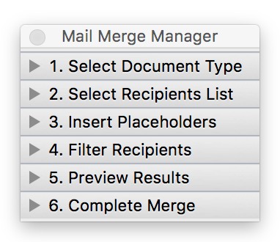

  - #1 - click on the drop down arrow beside “Create New” and select “Form Letters.”
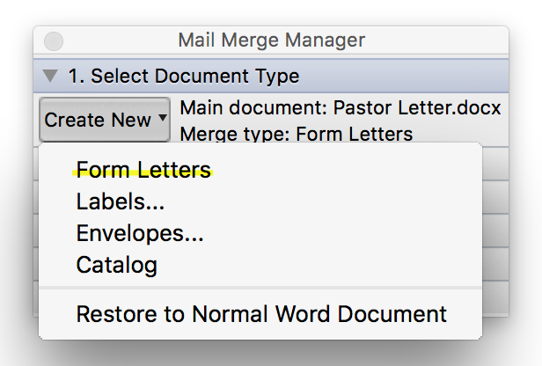

  - #2 – click on the drop down arrow beside “Get List” then click on “Open Data Source.” Browse on your computer or thumb drive to find the “Pastor Merge” spreadsheet and select it.
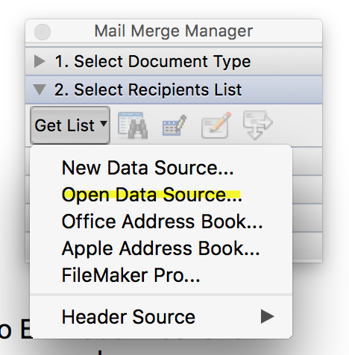

  - #3 – Drag two fields into the document to the appropriate spots in the letter: The placeholder for “Pastor” (or whatever you renamed the pastor first name field) should be placed in the salutation, and the placeholder for “Applicant” should be placed in the first paragraph. Be sure there is a comma after both fields. Delete the placeholders [PASTOR] and [APPLICANT] from the letter’s text.

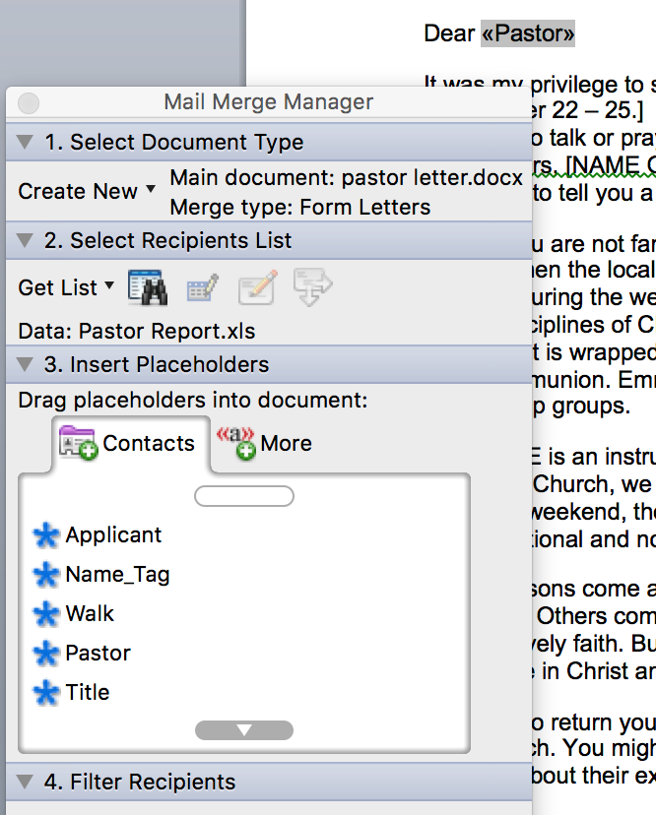

  - #4 – Skip. You do not have to filter recipients

  - #5 – To preview the results click on the “ABC” icon then click the forward arrow to see each of the letters. If edits are required you can return to previous steps.

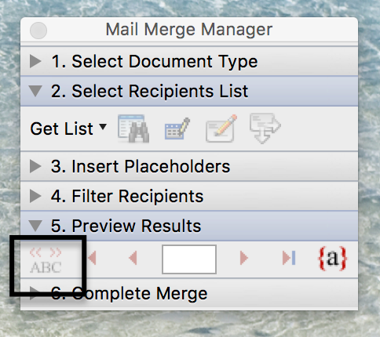

  - #6 – Complete the merge by clicking on the second icon, “merge to new document,” and save it on your thumb drive.

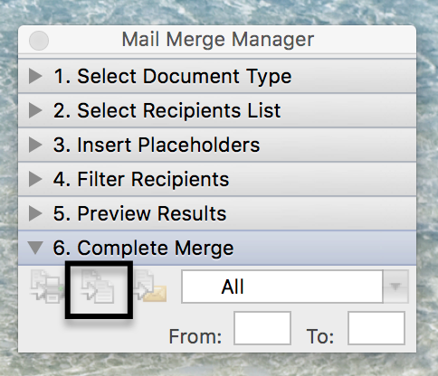

  - When you are satisfied that the letters have been generated correctly, print the letters.

- The Board Rep will have the Spiritual Director sign the letters on Thursday at camp then deliver the signed letters to the Agape Coordinator with the original “Pastor Report” (must contain pastor’s first and last names.)
- The Agape team will stuff and address all letters Friday morning, remembering not to seal them, in case the Spiritual Director desires to add a personal note to any letter at the end of the weekend.
- The Board Rep will mail all letters the week following the walk, pulling the letters for any pilgrims who did not complete the weekend.

