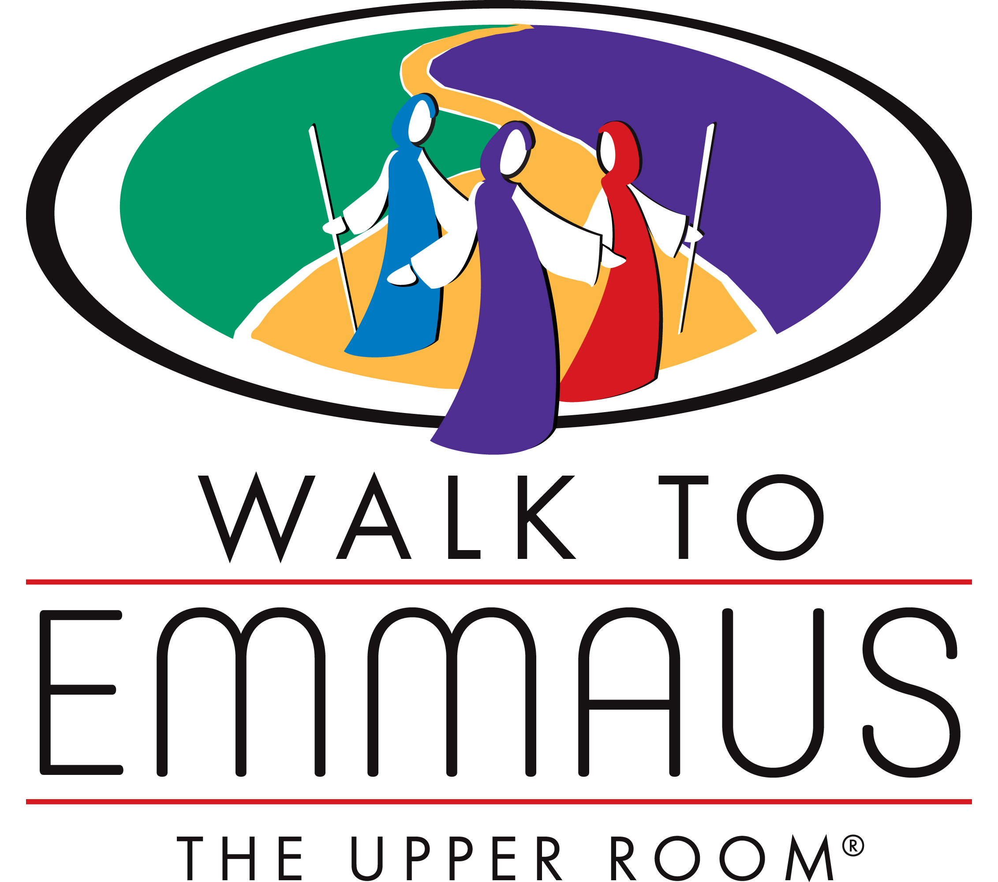
Helpful Emmaus Statistics
Over 1.4 million people have attended a Walk to Emmaus weekend
FACE TO FACE
18: Face to Face communities in the USA
CHRYSALIS
98: Chrysalis communities in the USA
36: Chrysalis communities outside the USA (in 12 countries)
EMMAUS
44: Countries in the world that have at least one Emmaus community
256: Emmaus communities in the USA
107: Emmaus communities outside the USA
NGWTE
1,200: Churches represented in NGWTE
11,000: Number of active members in NGWTE DatabaseE
21,000: Number of total members in NGWTE Database having had some role in Emmaus Weekends
15: Other Emmaus communities in GA (besides NGWTE)

