The Development Committee has completed the following during the past month:

* Committee Chair
  + Has moved out of State
  + Board will replace Chair by end of year
  + Request next Chair continues with Donation communication and Kindful platform
* Campaigns Update
  + Total Donations Received $12,827
    - This does not include the Credit Card Fees (~3%) of approximately $385
    - Approximate net = $12,442
  + “Do You Miss Me”
    - Raised $2,560 in donations
  + $5 For Faith \ $Do You Remember?
    - Raised $10,267 in donations
  + 15 Recurring Donors at $468.34/Month
    - $5,620.08 annual donation rate
    - $31.22 monthly recurring donation per Donor
  + 134 Donors
    - 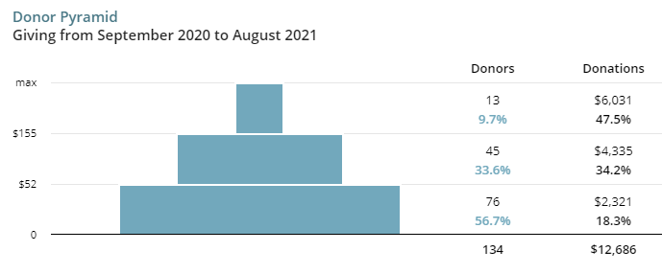
  + 36 Recurring Donors
    - Monthly Donations ~$395
      * Estimated Annual Donations from Recurring Donors = $4740

End

MLW